Overview of EMF 24 Policy Scenarios

Allen A. Fawcett*, Leon C. Clarke**, Sebastian Rausch***, John P. Weyant****

The Energy Modeling Forum 24 study included a set of policy scenarios designed to compare economy wide market-based and sectoral regulatory approaches of potential U.S. climate policy. Models from seven teams participated in this part of the study assessing economy-wide cap-and-trade climate policy and sectoral policies in the transportation and electric sector in terms of potential greenhouse gas emissions reductions, economic cost, and energy systems implications. This paper presents an overview of the results from the U.S. policy scenarios, and provides insights into the comparison of results from the participating models. In particular, various metrics were used to compare the model results including allowance price, the efficient frontier, consumption loss, GDP loss, and equivalent variation. We find that the choice of economic metric is an important factor in the comparison of model results. Among the insights, we note that the carbon price should cautiously be considered when other non-cap sectoral policies affecting emissions are assumed in tandem. We also find that a transportation sector policy is consistently shown to be inefficient compared to an economy-wide cap-and-trade policy with a comparable level of emissions reductions.

1. INTRODUCTION

In the absence of comprehensive legislation to curb greenhouse gas (GHG) emissions in the United States, policymakers have been pursuing climate change mitigation through sector or technology-specific regulatory measures. Comprehensive climate policies would cover most or all sources of GHG emissions and potentially incentivize reductions at least cost through a market mechanism—such as a carbon tax, cap-and-trade system, or hybrid mechanism—by achieving an equalization of marginal abatement costs across participants (Metcalf, 2009). Sectoral and regulatory measures, by contrast, require that GHG emissions reductions be achieved through compliance with sector-specific technology or efficiency targets. The policy scenarios of the EMF 24 exercise are based on combinations of three different types of national policy instruments: an economy-wide cap-and-trade policy, a transportation policy representing a Corporate Average Fuel Economy (CAFE) standard for light-duty vehicles (LDV), and a clean or renewable energy standard for electricity. These policy scenarios do not reflect any specific legislative or administration policy proposals, but instead are intended to represent more generic versions of economy wide and sector specific policies. Questions that are addressed are: (1) what are the potential implications of transportation and electric sector regulatory approaches to emissions reductions that are roughly consistent with widely discussed goals for the reduction of greenhouse gas emissions? (2) How do the separate regulatory policies behave on their own, and how do they interact with an economy-wide climate policy meant to meet this goal? (3) What are the costs of different policy architectures? (4) How might technological improvements and technological availability influence the answers to the above questions?
The EMF 24 study explores these questions through a comparison of results from seven modeling teams across seven standardized climate policy scenarios. Each modeling team was required to provide results related to economics, emissions, and energy systems for reference and policy scenarios. Policy assumptions are combined with two sets of coordinated technology assumptions for each individual or group of technologies: one set with pessimistic-technology assumptions representing evolutionary improvements in a technology, and a second set of optimistic-technology assumptions representing plausibly optimistic improvements. Modelers were free to make their own decisions on demographics, baseline GDP growth and energy consumption, and technology availability.
The remainder of this paper proceeds as follows. Section 2 details the study design and includes a list of modeling teams and scenarios. Section 3 and 4 provide results from the study on emissions pathways and the cost-effectiveness of climate policies considered here, as well as an exploration of differences in results across models and various cost and emissions metrics. Section 5 summarizes the results.

2. OVERVIEW OF THE STUDY DESIGN

2.1 Scenario Design

The scenarios in this study are built from combinations of technology assumptions and policy assumptions. Table 1 summarizes the scenarios. The ‘Technology Overview of EMF 24’ (Clarke et al., 2013) in this volume describes the technology assumptions used in this study, and the policy assumptions are described below. Two of the policy assumptions, the baseline and the 50 percent cap-and-trade scenarios, are run for all of the technology assumptions, and are further explored in Clarke et al. (2013). This paper explores the full set of policy assumptions, which are modeled for two specific sets of technology assumptions, a ‘optimistic CCS / nuclear’ set of technology assumptions that allow carbon capture and storage (CCS) and Nuclear technologies, and have pessimistic assumptions about renewable energy (RE); and a ‘optimistic RE’ set of technology assumptions that do not allow CCS, phase out nuclear power, and have optimistic assumptions about bioenergy, wind and solar. Both of these sets of assumptions include optimistic assumptions about end use technology.

Table 1. EMF 24 scenario matrix
Technology Dimension
 |  | Optimistic | Single Technology Scenarios |  |  |  | Combined Sensitivities |  | Pessimistic
End Use Technology |  | Optimistic | Pessimistic | Optimistic | Optimistic | Optimistic | Optimistic | Pessimistic | Pessimistic
CCS |  | Optimistic | Optimistic | Pessimistic | Optimistic | Optimistic | Pessimistic | Optimistic | Pessimistic
Nuclear |  | Optimistic | Optimistic | Optimistic | Pessimistic | Optimistic | Pessimistic | Optimistic | Pessimistic
Wind & Solar |  | Optimistic | Optimistic | Optimistic | Optimistic | Pessimistic | Optimistic | Optimistic | Pessimistic
Bioenergy |  | Optimistic | Optimistic | Optimistic | Optimistic | Pessimistic | Optimistic | Optimistic | Pessimistic
Policy Dimension
Baseline
0%
Cap & Trade
10%
Cap & Trade
20%
Cap & Trade
30%
Cap & Trade
40%
Cap & Trade
50%
Cap & Trade
60%
Cap & Trade
70%
Cap & Trade
80%
Cap & Trade
CAFE
RPS
CES
CAFE + RPS
CAFE + RPS + 50% C&T

Seven policy architectures are explored in this study: (1) baseline or reference scenarios with no policy, (2) cap-and-trade scenarios of varying stringency, (3) combined electricity and transportation regulatory scenarios, (4) electricity and transportation regulatory scenarios combined with a cap-and- trade policy, (5) isolated transportation sector policy scenarios, (6) isolated electricity sector policy scenarios with a renewable portfolio standard (RPS), and finally (7) isolated electricity sector policy scenarios with a clean energy standard (CES). Each of the scenarios is described by the set of policies of which it is comprised. These are discussed in detail in Table 2.

Table 2. EMF 24 policy assumptions

Policy | Description
Reference | The reference scenario assumes no climate policy. It does, however, include, to the extent they can be modeled by the participating modeling teams, any existing energy or related policies that might influence GHG emissions.
XX% Cap & Trade | This represents the assumption of a national policy that allows for cumulative greenhouse gas emissions from 2012 through 2050 associated with a linear reduction from 2012 levels to X percent below 2005 levels in 2050, where X is the percentage reduction target associated with the scenario. The cumulative emissions are based on the period starting from, and including, 2013 and through 2050. With the exception of CO₂ emissions from land use and land use change, the cap covers all Kyoto gases (CO₂, CH₄, N₂O, HFCs, PFCs, SF₆) in all sectors of the economy that the particular model represents. This includes non-CO₂ land use and land use change emissions and emissions of GHGs not covered under many U.S. climate bills. CO₂ emissions from land use and land use change are not included in the cap. For models that do not operate on annual time steps, the first year with a positive price on carbon is after 2012 (e.g., 2015 in a model with 5-year time steps), but the cumulative emissions are still be based on an assessment of the emissions associated with a linear path starting from, and including, 2013 and through 2050. Banking of allowances is allowed, but borrowing of allowances is not permitted. Note that the 0, 50 and 80 percent cap-and-trade scenarios are modeled closely after the EMF 22 U.S. transition scenarios (Fawcett et al., 2009).
Renewable Portfolio Standard (RPS) | The RPS applies only to the electricity sector. In this context, renewable energy includes all hydroelectric power and bioenergy. The RPS is defined as 20 percent by 2020, 30 percent by 2030, 40 percent by 2040, and 50 percent by 2050. Banking and borrowing are not allowed. If modelers were unable to meet these requirements within their model, they were allowed to create a scenario that includes a less aggressive RPS, but one that can be met by the model.
Clean Electricity Standard (CES) | This policy is similar to the RPS, but also includes nuclear power, fossil electricity with carbon capture and storage (credited at 90 percent), and natural gas (credited at 50 percent) in the portfolio. Both new and existing generation from all eligible generation types may receive credit. Because many additional sources are allowed to receive credit, the targets are defined as linearly increasing from reference levels in the first year of the policy (the first model time-step after 2012) to 50 percent by 2020, 60 percent by 2025, 70 percent by 2030, 80 percent by 2035, 90 percent by 2040, and constant thereafter (note that the current share of clean energy in the U.S., as defined here, is 42.5 percent). Banking and borrowing are not allowed. All other characteristics are identical to the RPS.
New Coal CCS | This policy requires that all new coal power plants capture and store 90 percent or more of their CO₂ emissions.
Transportation Sector Policy | The transportation policy is a CAFE standard for light-duty vehicles (LDV) that specifies a linear increase in fuel economy of new vehicles, starting in 2012, to 3 times 2005 levels in 2050. If modelers do not have the ability to represent a CAFE policy, they can alternatively represent the policy as a cap that covers all LDV in the transportation sector, as defined in the particular model. This alternative policy is defined as a linear reduction in LDV emissions from 2012 levels to 55 percent below 2010 levels in 2050. Banking and borrowing are not allowed. It is understood that with rebound effects and differences in reference scenario, this LDV emissions cap policy structure will not be identical to the CAFE policy; however, we expect them to be similar (the 55 percent reduction in LDV emissions under the cap is consistent with the emissions reductions achieved in a test run of GCAM), and there are benefits to explicit analysis of CAFE standards. Note that biofuels, electricity, and hydrogen are assumed to be zero-emissions fuels for calculating the emissions cap.
Cap & Trade + Sectoral Policy | Combines the 50 percent cap-and-trade policy with the RPS, the new coal CCS requirements, and the transportation policy described above.

2.2 Modeling Teams

Though nine models participated in the EMF24 study, seven modeling teams participated in the full extensive menu of policy scenarios of the EMF 24, and the results of these models are the focus of this paper. The models include: the Applied Dynamic Analysis of the Global Economy model (ADAGE), from Research Triangle Institute; the Environment Canada Integrated Assessment Model (EC-IAM), from Environment Canada; the Future Agricultural Resources Model (FARM), from U.S. Department of Agriculture; the Global Change Assessment Model (GCAM), from the Pacific Northwest National Laboratory/Joint Global Change Research Institute; the NewERA model, from NERA Economic Consulting;; the U.S. Regional Economy, GHG, and Energy Model (US-REGEN), from the Electric Power Research Institute; and the U.S. Regional Energy Policy (USREP) model, from the MIT Joint Program on the Science and Policy of Global Change. These seven models were able to report policy cost metrics that are the focus of the analysis presented here.

2.3 Limitations of this Study

It is important to note some of the limitations of this study. First, while these scenarios comprise a broad set of different climate policies and span a wide range emissions reductions targets, many uncertainties have yet to be explored, and implementation details, such as permit allocation, cost containment mechanisms, and revenue recycling issues, were not addressed in the comparisons. Some, but not all, of these uncertainties have been addressed by modeling teams in their individual papers. Second, fully harmonizing technology cost assumptions across all models proved inherently difficult as there are significant differences in model structure, in particular with respect to how technology choice is represented in each model. Third, models have not been fully harmonized with respect to their representation of the U.S. fiscal system, in particular if and how they represent existing taxes (for example, income and payroll taxes, corporate income tax). This implies that the interaction of a given climate policy instrument with pre-existing fiscal (tax) distortions may differ across models. More generally, it should be noted that the rank-ordering of policy instruments depends significantly on how the rents from a cap-and-trade program are used. While we assume a per-capita based lump-sum recycling of the revenue, it is well-known from the literature (for example, Goulder et al., 1999) that using the carbon revenue to lower pre-existing distortionary taxes may yield substantial efficiency gains. Due to model differences in the representation of the fiscal system, this study is not able to explore this dimension further, but it is important to bear in mind that the estimated cost for the cap-and-trade policies presented below should be interpreted as an upper bound, i.e. cost may be smaller if the carbon revenue would be recycled by lowering marginal tax rates, and the welfare ranking vis-à-vis the regulatory policy choices may be altered. Fourth, the scenario design and model baselines were locked down in early 2012, so the baselines do not reflect policies that were later adopted (e.g. the light duty vehicle and corporate average fuel economy standards that were published in October 2012). Additionally, developments in energy markets such as the shale gas boom have altered baseline emissions projections since the EMF 24 scenarios were developed (e.g. the Energy Information Administration’s Annual Energy Outlook (AEO) for 2013 projects 2020 CO2 emissions to be 6 percent lower than the then current AEO 2011 projections). Despite the various limitations and uncertainties, clear insights emerged from this study.

3. EMISSIONS PATHWAYS

Figure 1 shows historic U.S. CO₂ emissions covered by the policies modeled and projected reference scenario emissions for each model. The reference case emissions pathways show a wide range of emissions projections across models, which is likely an important factor in explaining differences in costs among the participating models. Differing levels of emissions in the reference case imply different amounts of abatement required to meet the cap established in the cap-and-trade policies and the reductions targets implicitly specified in the sectoral regulatory approaches. Note that for most models, 2010 is a modeled year, and thus different input assumptions across models give rise to modest deviations from historic emissions in 2010. For a first group of models (US-REGEN, ADAGE, and GCAM) total U.S. CO₂ emissions in the reference case remain relatively flat over the 2010-2050 period while a second group of models models (USREP, NewERA, EC-IAM, and FARM) predict that emissions rise at roughly similar and constant rates reaching levels in 2050 that are 3-29 percent higher than emissions in 2010. Modeling teams in the first group expect significant reductions in carbon emissions per dollar of gross domestic product (GDP) even without focused climate policy, reflecting different baseline assumptions about recent and anticipated non-climate related regulatory policy changes, future energy prices, and economic growth as compared to the second group of models.
Figure 1. Historic and projected reference emissions–covered CO₂ – (Optimistic CCS/Nuclear)
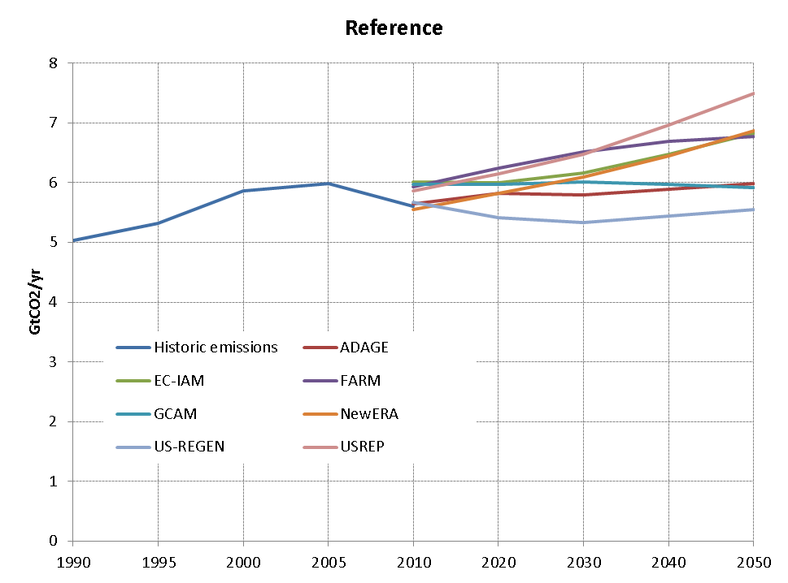

Figure 2. Emissions pathways –covered CO₂ – (Optimistic CCS/Nuclear)
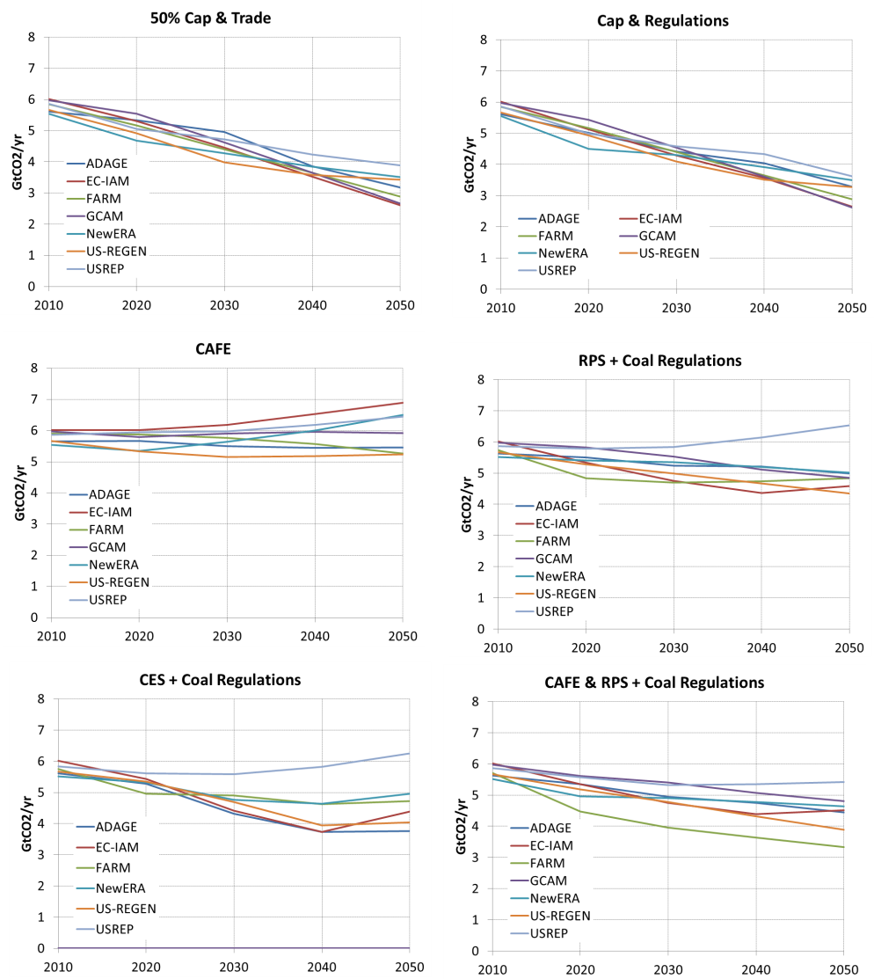
Figure 2 shows total U.S. covered CO₂ emissions in the six policy cases over time. The emissions pathways in the 50 percent cap-and-trade are more similar across all of the models than the pathways in the reference case, as all of the models face roughly similar, but not identical, cumulative targets. While the 2050 endpoint of allocation of allowances is identical for all models, each model starts from a slightly different point in 2012 due to differences in projected reference case emissions. Differences in pathways for covered CO₂ emissions in the scenarios involving a cap-and-trade policy also arise because targets are formulated in terms of greenhouse gases, and not all models include the non-CO₂ gases. Moreover, the models produce different inter-temporal allocations of allowances reflecting differences in terms of assumptions about cost and availability of new low-GHG technologies, and capital adjustment costs and the rate of capital stock turnover. Lastly, some models assume perfect foresight (ADAGE, NewERA, US-REGEN, and EC-IAM), in combination with explicit assumptions about post-2050 policy, while other models (USREP, FARM, and GCAM) are recursive-dynamic, i.e. decision-making is myopic and solely based on contemporaneous variables. Even in an otherwise identical model, the same policy constraint can produce different savings, consumption, and emissions trajectories depending on whether or not consumer expectations about future states of the economy are taken into account.

Figure 3. Cumulative 2012-2050 covered CO₂ emissions – (Optimistic CCS/Nuclear)

A key observation is that either of the regulatory policy measures directed towards the transportation and electricity sector, or a combination of both, yield substantially smaller emissions reductions over the 2010-2050 period compared to a 50 percent cap-and-trade policy. More specifically, the CAFE policy results in the smallest emissions reductions of all policies (or combinations thereof) considered. This reflects the fact that demand for private transportation services is relatively inelastic and that advanced low-carbon technologies in the private transportation sector are still costly. Among the policies focused on the electricity sector, CES policy (as specified here) is more effective in reducing CO2 emissions as compared to the RPS policy. Emissions reductions under the combined regulatory policies in the electricity and transportation sector come close but are somewhat lower than the total reductions achieved by a 50 percent cap-and-trade policy. Although the models differ in terms of the absolute level of projected emissions reductions, the preceding observations—as they relate to relative reductions across scenarios—are borne out consistently by each model.
Comparing the variation across models for a given scenario, it is noted that the spread in emissions outcomes is in general slightly larger for the scenarios involving regulatory polices as compared to the reference scenario or the cap-and-trade cases. This variation—reflecting to a large extent the different representation and assumptions of technology and abatement costs—should thus be viewed as providing a range of plausible outcomes that take into account the different modeling inputs and choices embedded in each simulation model.
Figure 3 compares cumulative covered CO₂ emissions from 2012-2050 across models and scenarios. For each scenario, we also report an average across models (black dash); in calculating the model average we assume that each model receives an equal weight. On average, the CAFE policy reduces cumulative emissions only by 8.3 Gt, while both the RPS and CES policies are more effective, reducing cumulative emissions by 34 and 47 Gt, respectively. A combination of both regulatory policies achieves on average a reduction of 43.7 Gt thus amounting to only about 60 percent of cumulative emissions reductions realized under the 50 percent cap-and-trade policy. Interestingly, the standard deviation of cumulative emissions across models for a given scenario does not vary much across scenarios. This suggests that much of the model differences in terms of CO₂ emissions pathways for each policy case in Figure 2 can be explained by factors—which are described above— that drive differences in the reference case. Put differently, while the models in this study, for a given policy instrument, show some variation with respect to the absolute magnitude of cumulative emissions reductions, differences in model projections become much smaller if initial model conditions, i.e. those describing models in the absence of an explicit climate policy, are taken into account. Figure 4 shows CO₂ emissions for the electricity and the combined transportation sectors in the reference and selected policy scenarios for each model. Several insights emerge from this graph. First, regulatory instruments in the electricity sector in the form of a RPS or CES policy lead to larger annual emissions reductions in all periods, and hence larger cumulative reductions, as compared to a CAFE policy, which targeted at the transportation sector.

Figure 4. Electricity and transportation CO₂ emissions – (Optimistic CCS/Nuclear)

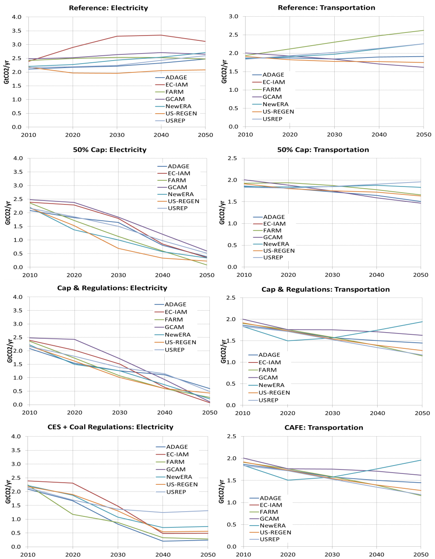

Second, the electricity sector offers less expensive abatement opportunities and a larger potential for reducing CO₂ emissions than does the transportation sector. This becomes evident when comparing the sectoral emission profiles under each regulatory policy with the 50 percent cap-and-trade case. While a policy that puts an explicit price on carbon incentivizes roughly the same amounts of emissions reductions in the electricity sector as a CES+coal CCS requirement policy, the 50 percent cap-and-trade policy reduces emissions in the transportation sector only very slightly. This is an important characteristic of a cap-and-trade policy, which does not force all sectors to reach specified targets but rather the aggregate emission reductions are achieved at the overall least cost of achieving the aggregate emissions reduction target. This implies that the cost of the last ton of emissions abated in the electricity sector is equal to the cost of the last ton of emissions abated in the transportation sector (i.e., that marginal abatement costs are equal).
Third, the sectoral emissions profiles under each respective non-cap and trade regulatory policy are very similar to the emissions observed under a policy that also includes a carbon cap to the sectoral policies. This suggests that each sectoral regulatory instrument is binding, and that additional emission reductions under a combined policy regime are mostly achieved outside of the electricity and transportation sectors. While virtually no difference in transportation sector emissions are discernible between the CAFE and cap-and-regulations cases, an explicit carbon pricing policy provides an incentive for additional reductions in electricity sector emissions beyond 2040 that would not be realized under a CES+new coal CCS requirements-only policy.

4. ECONOMIC IMPACTS

In this overview, we focus on four different metrics for measuring economic impacts: allowance price, consumption loss, GDP loss, and EV. The allowance price is a measure of the marginal cost of abating GHG emissions in a cap-and-trade program, and has been an important cost metric for policy makers in analyses of legislation such as the Waxman Markey bill (e.g. EPA 2009; EIA 2009; Fawcett et al. 2009). The remaining three metrics are measures of a policy’s aggregate economic cost. Consumption loss is a measure of the change in consumption of goods and services in the economy. It measures the reduction in the amount of goods and services households can purchase due to increases in energy prices and other costs resulting from GHG abatement. GDP loss combines the change in consumption with the changes in the other components of GDP: investment, government expenditures, and net exports. While policy makers are often interested in GDP loss as a metric of the overall impact on the economy, changes in consumption are sometimes a preferred cost metric because utility (and thus welfare) is a direct function of consumption. The final cost metric considered here is equivalent variation (EV), a measure of household welfare. EV is the difference between reference case household expenditures and the expenditures households would need to be as well off in the GHG reduction case if prices were held constant at reference case levels. For economists, EV is often the preferred cost metric; however, it is sometimes difficult to communicate to policymakers.
It is important to note that this study is a cost-effectiveness analysis with a primary focus of comparing the costs of reaching various GHG emission reduction goals. This study does not quantify the benefits of reducing GHG emissions, so the results cannot be interpreted as a cost-benefit analysis.

4.1 Allowance Prices

Figure 5 depicts allowance prices, expressed in 2005$ per ton of equivalent carbon dioxide ($/tCO₂e), for a 50 percent cap-and-trade policy with and without CAFE standards in the transportation sector and RPS + New coal CCS requirements in the electricity sector. For the cap-and-trade policy without sectoral policies, allowance prices range from $3.9/tCO₂e for GCAM to $51.9/tCO₂e for USREP in 2020, and from $67.3/tCO₂e for GCAM to $168.3/tCO₂e for USREP in 2050. Several factors lead to differences in allowances prices. First, a major driver of differing cost estimates is technology, or substitution possibilities available in the models. Higher capital costs for nuclear or CCS, or restrictions on the penetration rate of these technologies, would both tend to increase allowance prices. Second, a model with high growth in GHG emissions in the baseline after 2012 (for example, USREP) will have to abate more and will thus generate higher allowance prices. Third, the flexibility of the capital stock will influence how quickly old technologies can be phased out and new technologies can be adopted. Finally, models differ with respect to the assumed interest rates used for banking.

Figure 5. Allowance prices under cap-and-trade policy with and without sectoral polices – (Optimistic CCS/Nuclear)
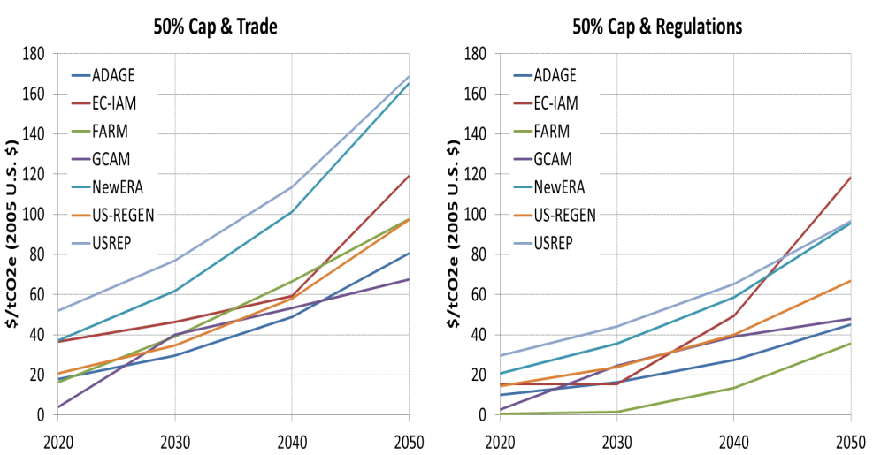

The dispersion of allowances prices across models is reduced if regulatory policies are added to the cap-and-trade policy. In 2020, FARM has the lowest ($0.7/tCO₂e) and USREP the highest allowance price ($29.7/tCO₂e). In 2050, allowance prices range from $44.9/tCO₂e for ADAGE to $118.4/ CO₂e for EC-IAM. Smaller differences in allowance prices across models are largely explained by the fact that allowance prices are significantly lower if sectoral regulatory policies are part of the policy package. Emissions reductions forced by CAFE and RPS + New coal CCS requirements mean that in the presence of an economy-wide cap less abatement has to occur elsewhere, thus reducing the demand for allowances and their equilibrium price.
One important insight of this study is that the allowance price is a poor metric of the societal cost of reducing GHG emissions if regulatory instruments are part of a climate policy package. In such cases, focusing on the carbon price can hide substantial costs and is likely to lead to false policy conclusions. We therefore now turn to other metrics of a policy’s aggregate economic cost that are more appropriate under such circumstances.

4.2 Efficient Frontier – Cap & Trade

Comparing policy costs across scenarios that reach different levels of GHG emissions can be difficult, and comparing those scenarios across models that require different amounts of abatement to achieve the same GHG levels only compounds the difficulty. When analyzing a single cap-and-trade policy for example, a cost-effectiveness study can compare how policy costs evolve over time across scenarios that vary things other than the cap level. In order to compare cost-effectiveness across models and scenarios, Figure 6 plots the net present value (NPV) of total consumption loss, discounted at 5 percent per year, on the vertical axis against the 2013 through 2050 and cumulative reductions in covered CO₂ emissions on the horizontal axis. Measuring costs in terms of the NPV of total costs is a cumulative cost measure that allows us to remove the time component associated with when costs are incurred and more readily compare across models and scenarios. Given that climate change is primarily a stock pollutant problem, a non-discounted cumulative measure of emissions is also appropriate and further allows us to ignore or remove the time dimension. Finally, since reference case emissions differ between models, measuring cumulative abatement on the horizontal axis means that the cost-effectiveness can be compared between models based on similar levels of effort.
Figure 6 presents all of the cap-and-trade scenarios, from 0 percent reduction from 2005 levels by 2050 to 80 percent reduction from 2005 levels by 2050, for the ‘optimistic CCS / nuclear’ technology assumptions. Each differently colored line connects points representing successively more stringent cap-and-trade policies in a particular model. The leftmost solid square for each line represents the 0 percent cap-and-trade policy that holds emissions constant at 2005 levels, and the rightmost solid square represents the 80 percent cap-and-trade policy that lowers emissions to 80 percent below 2005 levels by 2050. In the middle of each line is a solid square representing the 50 percent cap-and-trade policy, and the smaller hollow squares in between represent additional cap-and-trade policies incremented by ten percentage points of additional reductions from 2005 levels by 2050. We can think of each of these lines as an efficient frontier for one particular model. For the class of models represented in this figure, the most efficient policies for reducing GHG emissions generally allow for maximal “when”, “where”, and “what” flexibility, i.e. allow banking and borrowing allowances across time, equalize the cost of abatement across all emissions sources, and cover all greenhouse gases. One important caveat is that allowance revenue in these scenarios is recycled through lump sum transfers to households. If instead, however, allowance revenue generated by the cap-and-trade policy was used to lower other distortionary taxes, the efficient frontier would shift down or to the right.
Figure 6. Efficient frontiers – consumption loss vs. covered CO₂ – (Optimistic CCS/Nuclear)
As an example of how Figure 6 helps to compare cost-effectiveness across models, consider the 50 percent cap-and-trade scenarios in ADAGE and NewERA. If we just compare the NPV of total consumption loss, this scenario is 98 percent more costly in NewERA ($2.1 trillion) than in ADAGE ($1.1 trillion). This comparison gives an incomplete picture of the cost of abatement in these two models, because they have very different assumptions about baseline emissions levels, and the amount of abatement required to meet the 50 percent cap-and-trade target is substantially different: a 51 GtCO₂e reduction in ADAGE compared to a 74 GtCO₂e reduction in NewERA. Figure 6 allows us to see that the level of abatement in the ADAGE 70 percent cap-and-trade scenario is actually equivalent to the level of abatement in the NewERA 50 percent cap-and-trade scenario, and comparing the costs of those two scenarios, they are almost identical. This figure shows that while these two models have very different costs in specific scenarios, costs for any given level of abatement are similar, and the efficient frontiers for these two models look similar.

4.3 Sectoral & Regulatory Approaches Compared to the Efficient Frontier

In this section, we explore how the sectoral and regulatory policies compare to the efficient frontiers presented in Figure 6, and how that comparison is affected by changing cost and emissions metrics. We will also further explore the differences between consumption loss and GDP loss cost metrics by looking at the impacts on different components of GDP. Then we will investigate some of the model differences that are driving some of the specific results seen here.

4.3.1 Comparison of Cost Metrics

Figure 7 takes the same efficient frontiers represented by the cap-and-trade scenarios for each model in Figure 6, presents them in separate smaller plots for each model, and overlays the sectoral and regulatory scenarios. For the points off of the cap-and-trade efficient frontier line, the green square represents the transportation policy scenario, the light blue square represents the RPS scenario, the purple square represents the CES scenario, the yellow square represents the combined RPS and transportation policy scenario, and the red square represents the cap-and-regulations scenario, which combines the 50 percent cap-and-trade policy with the CAFE, RPS, and new coal CCS requirements.

Figure 7. Sectoral & regulatory policies and efficient frontiers – C loss vs. covered CO₂

The first thing to notice in Figure 7 is that for the most part the sectoral and regulatory policies fall inside (i.e., above) the efficient frontier. In all models the cap-and-regulations scenario generates similar abatement levels to the 50 percent cap-and-trade scenario, differing by at most 4 percent (CGAM and EC-IAM), with higher cumulative consumption loss. However, the difference in consumption loss between these two scenarios differs considerably between models; in USREP, the cap-and-regulations scenario is 62 percent more costly than the 50 percent cap-and-trade scenario, whereas in EC-IAM it is 230 percent more costly. We can also compare the cap-and-regulations scenario (yellow squares in Figure 7) with the combined sectoral policy scenario. All of the models show that the percentage increase in cumulative abatement from adding a 50 percent cap-and-trade policy to the combined CAFE, RPS, and new coal CCS requirement policies is greater than the percentage increase in cumulative costs. The combined regulatory scenario can then be compared to the scenarios representing its constituent policies separately. In three of the models, NewERA, US-REGEN and ADAGE, compared to the RPS scenario, the CAFE scenario generates less abatement with greater consumption loss. For USREP, FARM and EC-IAM, the RPS still generates greater abatement, but at greater cost than the CAFE policy. Finally the CES scenario can be compared to the RPS scenario. This comparison is heavily dependent on the technology assumptions. In the ‘optimistic CCS / nuclear’ scenarios presented in Figure 7, all of the models find greater abatement in the CES scenario. The US-REGEN, NewERA, FARM and EC-IAM models, however, also find lower costs in the CES scenario, while USREP, and ADAGE find higher costs in the CES scenario. Interestingly, US-REGEN, NewERA, and ADAGE all show the CES to lie beyond the efficient frontier, though this effect disappears in ADAGE when considering all covered GHG emissions, and for NewERA the effect is dependent on the technology assumptions used.
Next, we look at how these results change when we use EV as a cost metric instead of consumption loss. The solid points and lines in Figure 8 present the results for all scenarios using EV as the cost metric; and for comparison, Figure 8 also presents all of the results from Figure 7, using consumption loss as the cost metric, as points using faded colors, and a dashed line for the consumption loss of the efficient frontier.
Looking at only the efficient frontiers all of the models show that costs in terms of EV are very similar, but generally slightly less than consumption loss. USREP finds larger percentage differences in the low-cost, low-abatement cap-and-trade policies (EV costs are 120 percent less than consumption loss in the 0 percent cap-and-trade scenario, though costs are near zero). As the cap-and-trade scenarios, however, become more aggressive and costs rise, the percentage difference falls to 32 percent for the 50 percent cap-and-trade policy and to 13 percent for the 80 percent cap-and-trade policy. NewERA shows a similar pattern; EV is 18 percent less than consumption loss in the 10 percent cap-and-trade scenario, falling to 7 percent less in the 80 percent cap-and-trade scenario. For US-REGEN, EV and consumption loss are almost identical, with EV costs being just 2 percent less than consumption loss in all cap-and-trade scenarios. ADAGE’s EV costs are 12 to 17 percent less than consumption loss. FARM EV costs are between 8 percent less and 1 percent greater than consumption loss.

Figure 8. Sectoral & regulatory policies and efficient frontiers – EV vs. covered CO₂

Turning to the sectoral and regulatory policies, for some models the choice of cost metric impacts the relation between these policies and the efficient frontier, while for other models this relationship is largely the same under both EV and consumption loss. The biggest change occurs in the USREP and NewERA models. While the cap-and-trade policies were universally less expensive in EV terms than consumption loss terms in USREP, the sectoral and regulatory policies are all more expensive in EV terms. Furthermore, these policies are not uniformly impacted by the choice of cost metric. The RPS and CES policies are respectively just 3 and 7 percent more expensive in EV terms, but the CAFE policy is 78 percent more expensive. NewERA finds the CAFE and RPS policies to be respectively 15 percent and 6 percent more costly in EV terms compared to consumption loss, while the CES to be 31 percent less costly. The EV of the combined regulatory policies is 11 percent less than consumption loss in NewERA, and the EV of the cap-and-regulations scenario is 40 percent less than consumption loss.
Figure 9 builds upon Figure 8 by adding points that use GDP loss as the cost metric, using solid points and lines; keeping the consumption loss metric in the figure as faded points and dashed lines; and keeping the EV loss metric now using faded outlined points and dotted lines. GDP loss shows the most dramatic differences from the other cost metrics, with the largest differences seen in the USREP and US-REGEN models. USREP finds that the cap-and-trade policies in the efficient frontier are between approximately 220 percent and 590 percent more expensive in GDP loss terms than consumption loss terms, with the largest percentage difference in the 30 percent cap-and-trade scenario and the smallest in the 80 percent cap-and-trade scenario. US-REGEN similarly shows the 10 percent cap-and-trade scenario to be approximately 900 percent more expensive in GDP loss terms compared to consumption loss, and the difference falls as the cap-and-trade policies become more aggressive, down to approximately 250 percent in the 80 percent cap-and-trade scenario. In the other models, the difference between GDP and consumption loss is much less pronounced for the cap-and-trade polices. NewERA finds the policies on the efficient frontier are 26 to 73 percent more expensive in GDP loss than consumption loss. The GDP loss metric in FARM is 29 percent costlier than the consumption loss metric in the 0 percent cap-and-trade scenario, rising to 37 percent in the 80 percent cap-and-trade scenario. In ADAGE the 40 percent cap-and-trade scenario is 55 percent more costly using GDP loss as the cost metric than it is using consumption loss, and the difference increases to 76 percent for the 80 percent cap-and-trade scenario. Finally, EC-IAM shows very large percentage differences between GDP loss and consumption loss for the low abatement cap-and-trade scenarios where it finds near zero consumption loss but positive GDP loss, but the difference is much less as the stringency of the policy increases, 140 percent greater costs using GDP loss in the 50 percent cap-and-trade scenario falling to 37 percent greater costs in the 80 percent cap-and-trade scenario.

Figure 9. Sectoral & regulatory policies and efficient frontiers – GDP Loss vs. covered CO₂
As we saw comparing EV to consumption loss, the relationship between GDP loss and consumption loss can be very different in the sectoral and regulatory policy scenarios compared to the cap-and-trade scenarios. For USREP, the CAFE scenario is 600 percent more expensive in GDP loss terms than in consumption loss terms, but the RPS and CES scenarios are only 14 and 23 percent more expensive. US-REGEN also sees a huge difference between the CAFE policy and the electricity sector policies in this regard. The CAFE scenario in US-REGEN is approximately 330 percent more expensive whereas the RPS and CES policies have GDP losses that are respectively approximately 150 and 44 percent smaller than consumption losses.

4.3.2 Exploration of Cost Metric Differences

For a given policy, differences between the consumption loss and the EV metric are very small across models. A key conceptual difference between the EV metric as opposed to the consumption loss metric is that it values private utility derived from leisure consumption. A standard way of modeling labor supply in economy-energy general equilibrium models is that households face an labor-leisure trade-off whereby the amount of labor supplied in equilibrium is determined as part of the utility maximizing behavior. As the EV metric is based on the utility function, it does take into account the policy impact on labor supply decisions. A carbon pricing policy raises the price of consumption relative to leisure, and hence households reduce the labor supply substituting towards leisure. The flexibility for consumers to avert some of the price increase by demanding less goods and services and by demanding more leisure time implies smaller economic costs if an EV metric is used instead of a pure consumption-based metric. For all models, the EV metric yields smaller costs of a cap-and-trade policy than the consumption loss metric, thus confirming the above reasoning.
Another potential difference between the EV and consumption loss metric is that in models with forward-looking behavior (e.g., US-REGEN), the discount rate used to calculate the NPV costs in Figure 9 differs from the discount rate implicitly used in the model. Also, note that US-REGEN assumes that labor supply is fixed exogenously and hence there is no difference between that consumption loss and EV that derives from leisure consumption.
Turning to the comparison of GDP with the consumption loss/EV metrics, it is useful to start with some general remarks about the issues related to GDP as a measure of well-being. GDP is the most widely-used measure of economic activity. GDP mainly measures market production, however it has often been treated as if it is a measure of economic well-being. Conflating the two concepts can lead to misleading indications about how well-off people are and misrepresent the impacts of policy choices. Material living standards are more closely associated with measures of real household income, and consumption–production can expand while income decreases or vice versa when account is taken of depreciation, income flows into and out of a country, and differences between the prices of output and the prices of consumer products. When evaluating material well-being, economists therefore prefer to look at income and consumption rather than production.

4.3.3 Comparison of Emissions Metrics

Figure 10 shows the NPV of consumption loss versus cumulative emissions reductions for sectoral regulatory and cap-and-trade policies where on the horizontal axis, unlike for previous figures that showed cumulative covered CO₂ emissions, cumulative GHG emissions reductions, including the six Kyoto gases, are shown. Four of the seven models in this study (USREP, ADAGE, EC-IAM, and GCAM) include non-CO₂ GHGs. This figure clearly shows that one important determinant of cost-effectiveness for a carbon pricing policy is the flexibility to choose “what” greenhouse gas to abate, thus ensuring that marginal abatement costs across multiple gases are equalized. For all four models that include non-CO₂ GHGs the efficient frontier is shifted to the right, indicating that a carbon pricing policy that only targets CO₂ foregoes cheap abatement opportunities associated with non-CO₂ GHGs.

Figure 10. Sectoral & regulatory policies and efficient frontiers – covered CO₂ vs. covered CO₂e

Note that for all cap-and-trade scenarios it is assumed that all GHGs, to the extent modeled, are included under the cap, i.e. the modeling teams were not asked to run a cap-and-trade policy just targeted at CO₂. As a result, economic costs are identical, and the efficient frontiers including all GHGs are just right-shifted versions of the ones that show only CO₂ on the horizontal axis. Cumulative GHG emissions reductions for sectoral regulatory policies remain virtually unchanged as these policies are designed to target CO₂ only.
It is important to realize that for relatively low abatement levels the inclusion of non-CO₂ GHGs in a cap-and-trade policy yields bigger percentage increases in cumulative CO₂e emissions reductions compared to more stringent targets (while holding economic costs constant). For more ambitious targets, the efficient frontiers for the two cases tend to move more in parallel, thus implying that the percentage increase in cumulative emissions reductions is decreasing in the stringency of the policy. For designing cost-effective cap-and-trade policy, it is therefore of particular importance to include non-CO₂ GHGs when policy targets with a low to medium stringency are considered.

4.3.4 Further Exploration of Model Differences

Figure 8 shows that for some models (US-REGEN, NewERA, ADAGE) the CES+New coal CCS requirements have smaller welfare impacts (in terms of EV) than an economy-wide cap with a comparable level of overall abatement. One question arising from Figure 8 is why do the costs of the technology mandate lie below the efficient frontier.
In a first-best world without pre-existing distortionary taxes ( for example, income, payroll, and sales taxes), regulatory policies always lead to larger costs of carbon abatement than a carbon tax or permits as the former fail to equalize the marginal cost of abatement across sources and users. The welfare ranking of these policy instruments in a second-best setting, however, is ambiguous. While it has been shown that the presence of pre-existing taxes may significantly raise the cost of carbon pricing policies relative to their costs in a first-best world, the cost increase is even larger for policies that do not use the carbon revenues to finance cuts in distortionary taxes (see, for example, Goulder et al., 1999, and Parry et al., 1999). By driving up the price of carbon-intensive goods relative to leisure, a carbon pricing policy tends to compound the factor-market distortions created by pre-existing taxes, thereby creating a negative welfare impact termed the tax-interaction effect. If the carbon revenue is returned as a lump-sum payment to households, as is the case in the cap-and-trade scenarios in our study, the revenue-recycling effect is zero, implying that the overall impact of pre-existing taxes is to raise costs. In turn, an electricity sector policy that yields a smaller increase in the consumer price of electricity as compared to a carbon-pricing policy may actually be a more efficient way to achieve a comparable level of abatement, given carbon-pricing's vulnerability to distortionary tax interaction. In addition, such a welfare ranking of policies is also facilitated by the fact that the CES policy is roughly equivalent to an electric-only cap plus an output subsidy. Thus, it is allocating abatement efficiently within the electric sector, but it is inefficient in terms of both substitution at the end-use level as well as abatement in non-electric sectors. Moving to an economy-wide cap should correct these remaining inefficiencies and reduce the total welfare impact. However, moving to a cap (i.e., removing the output subsidy for electricity and adding a tax on non-electric fuels) introduces a countervailing inefficiency through the distortionary factor tax interaction.
In models with relatively steep abatement costs in the non-electric sectors and a relatively flat curve in the electric sector, the efficiency gain from the economy-wide coverage in terms of lowering total abatement cost is not very large, and as a result the CES is very close to efficient abatement allocation anyway (but without raising fuel prices much). This situation tends to be more characteristic of models that adopt a bottom-up representation of electricity generation and transmission (US-REGEN, NewERA, and ADAGE). On the other hand, models with a top-down representation of electricity generation and low-cost abatement options in non-electric sectors (USREP, FARM, EC-IAM) estimate that the regulatory policies for the electricity sector are less efficient than an economy-wide cap-and-trade policy. Furthermore, it is important to bear in mind that model results can differ according to how well pre-existing tax distortions are represented.
In summary, the existence of prior distortionary taxes in an economy can potentially eliminate the cost advantage of market-based instruments like carbon permits or a carbon tax over a Clean Energy Standard in the electricity sector. In particular, the likelihood of such an outcome may be increased if the carbon revenue that is generated through an explicit carbon pricing policy is not used to fund cuts in (marginal) distortionary taxes.
The presence of distortionary taxes, however, does not necessarily eliminate the cost advantage of any sectoral regulatory policies as can be seen by comparing the policy costs for the transportation sector policy with the efficient frontier. All models consistently estimate that a transportation sector policy is hugely inefficient compared to an economy-wide cap-and-trade policy with a comparable level of emissions reductions. There are two reasons for this. First, the abatement cost curve in the transportation sector is very steep compared to other sectors, largely because transportation demand is relatively inelastic and low-carbon technologies for the private transportation sector are still very costly. Second, a policy focused only on the transportation sector forgoes cheap abatement opportunities in the electricity sector, mainly associated with coal-fired power plants, and in non-electric sectors. In all models, both of these effects seem to dominate the negative tax interaction effect.
Model differences in terms of the efficiency costs of a transportation sector policy (relative to the efficient frontier) reflect different assumptions about future fuel economy improvements and market penetration rates of advanced low- or zero-carbon vehicles.

4.3.5 Comparing ‘Optimistic CCS / Nuclear’ and ‘Optimistic Renewable Energy’ Scenarios

The previous sections have all focused on the ‘optimistic CCS / nuclear’ scenarios instead of the optimistic RE scenarios, and for the most part the insights that have been drawn from these scenarios are robust across both sets of technology assumptions. In this section we investigate some of the differences between the two sets of technology assumptions. Figure 11 compares the NPV of cumulative costs in the optimistic RE scenarios to the costs in the ‘optimistic CCS / nuclear’ scenarios, using consumption loss as the cumulative cost metrics Each bar represents the NPV of cumulative consumption loss in a optimistic RE scenario, relative to the optimistic RE baseline, less the NPV of cumulative consumption loss in a ‘optimistic CCS / nuclear’ scenario, relative to the ‘optimistic CCS / nuclear’ baseline. Positive bars represent the additional cost of meeting the policy goals of a scenario in the optimistic RE scenario relative to the costs of meeting those goals in the corresponding ‘optimistic CCS / nuclear’ scenario.
Three of the models (NewERA, EC-IAM and FARM) show a similar pattern across the cap-and-trade scenarios of the optimistic RE scenarios becoming relatively more expensive than the ‘optimistic CCS / nuclear’ scenarios as the required abatement increases, with the 80 percent cap-and-trade scenario being $1.0 trillion (FARM) to $1.1 trillion (NewERA and EC-IAM) more expensive under the optimistic RE assumptions. The other three models (ADAGE, US-REGEN and USREP) find much smaller cost differences between the two technology assumptions in the cap-and-trade scenarios. The CES and the RPS policies for the electricity sector have some of the largest cost differences across technology assumptions. The RPS requires penetration of renewable technologies and gives no credit to nuclear or CCS, so unsurprisingly all models find the RPS to be less costly under the optimistic RE technology assumptions. In contrast, the CES treats all zero carbon generation technologies equally, and all models, except for USREP, find it to be more expensive under the optimistic RE technology assumptions. For both the CES and the RPS, compared to cap-and-trade policies that achieve similar emissions reductions, the costs of the electricity sector policies are more sensitive to the assumptions about technology.

Figure 11. Difference in Difference: NPV of Cumulative Consumption Loss - Optimistic RE Scenarios less Optimistic CCS / Nuclear Scenarios

6. CONCLUSION

The EMF 24 exercise was designed to explore the differences and interactions between an economy-wide cap-and-trade approach to limiting greenhouse gas emissions, and a sectoral and regulatory approach to climate policy. The seven models in EMF 24 generally find that for similar levels of abatement, a cap-and-trade policy that places a price on all greenhouse gas emissions is more cost effective than sectoral or regulatory approaches that are limited in coverage and therefore more prescriptive in how emissions reductions are to be achieved. Furthermore, when sectoral and regulatory policies are combined with a cap-and-trade policy, the allowance price may be reduced compared to the cap-and-trade policy alone, but the cost- effectiveness is generally decreased as well. This difference between allowance price impacts and cost effectiveness measures points to another insight from this study, namely that the choice of cost metrics matters. For measuring the true welfare impacts of a policy, EV is the metric preferred by economists, but it is not produced by all models and can be difficult to explain to policy makers. For the models that report both, consumption loss impacts are very similar to EV loss. GDP loss on the other hand is dramatically higher than EV or consumption loss in some models, while only slightly higher in others, making it particularly problematic to use GDP loss to compare costs across models. The EMF 24 exercise demonstrates some of the uncertainty in estimating policy costs by presenting the cross model range of cost estimates, and by analyzing all of the policy options under different technology assumptions, some of the within model uncertainty can be seen as well.
This paper just scratches the surface of information contained in the EMF 24 modeling runs. The technology overview paper (Clarke et al., 2013) in this volume further explores the baseline scenarios and the implications of the full set of technology assumptions. In the rest of this volume the individual modeling teams present their detailed exploration of results and insights from each participating model. Finally, all of the model output data from the EMF 24 exercise will be available from the EMF website and can be used to further explore the issues presented here and many more.
REFERENCES

Clarke, Leon.C., Allen.A. Fawcett, John P. Weyant, James McFarland, Vaibhav Chaturvedi, and Yuyu Zhou (2014). “Technology and U.S. Emissions Reductions Goals: Results of the EMF 24 Modeling Exercise.” The Energy Journal (this volume)

Environmental Protection Agency (2009). “EPA Analysis of the American Clean Energy and Security Act of 2009, H.R. 2454 in the 111th Congress.” Accessed at: www.epa.gov/climatechange/EPAactivities/economics/legislativeanalyses.html

Energy Information Administration (2009). “Energy Market and Economic Impacts of H.R. 2454, the American Clean Energy and Security Act of 2009.” Accessed at: www.eia.gov/oiaf/servicerpt/hr2454/index.html

Fawcett, Allen A., Katherine V. Calvin, Francisco C. de la Chesnaye, John M. Reilly, and John P. Weyant (2009). “Overview of EMF 22 U.S. transition scenarios.” Energy Economics, 31 S(2), 198-211

Fawcett, Allen A., Leon C. Clarke, and John P. Weyant. (2014). “Carbon Taxes to Achieve Emissions Targets – Insights from EMF 24.” in Volume Carbon Taxes and Fiscal Reform: Key Issues Facing US Policy Makers. Ed. Ian Parry. (Forthcoming)

Lawrence H. Goulder, Ian W.H. Parry, Roberton C. Williams III, and Dallas Burtraw (1999). “The cost-effectiveness of alternative instruments for environmental protection in a second-best setting.” Journal of Public Economics 72, 329-360.

Metcalf, Gilbert E. (2009). "Market-based Policy Options to Control U.S. Greenhouse Gas Emissions." Journal of Economic Perspectives, 23:2, 5-27.

Parry, Ian W. H., Roberton C. Williams III, and Lawrence H. Goulder (1999). “When Can Carbon Abatement Policies Increase Welfare? The Fundamental Role of Distorted Factor Markets.” Journal of Environmental Economics and Management 37, 52-84

Stiglitz, Joseph E., Amartya Sen, and Jean-Paul Fitoussi, “Report by the Commission on the Measurement of Economic Performance and Social Progress.” Technical Report September 2009. Accessed at: www.stiglitz-sen-fitoussi.fr/documents/rapport_anglais.pdf

APPENDIX

A.1 Components of GDP

Section 4.3.2 explored the differences between cost metrics. One of the interesting results from Figure 9 is that for some of the models the three cost metrics all provide costs that are of a similar magnitude, while for other models GDP loss is dramatically greater than consumption loss or EV. In order to shed some light on the differences between models, Figure A.1 decomposes GDP loss into changes in the components of GDP: consumption, investment, government expenditures, exports and imports. Explaining why the components of GDP differ between models is beyond the scope of this paper, but some of the patterns here give more context for the differences between the consumption loss and GDP loss cost metrics. We see for models for which the GDP and the consumption loss or EV metrics show similar magnitude of costs (FARM and EC-IAM) that the consumption loss represents a large fraction of the total GDP loss, whereas for the other models (NewERA, US-REGEN, USREP) the consumption loss represent a relatively smaller fraction.

Figure A.1. NPV of Components of Cumulative GDP Loss

A.2 Primary Energy

Figure A.2 shows primary energy in the reference scenario across all seven participating models. Growth in primary energy over the next four decades varies across models, with energy consumption in 2050 ranging from a low in US-REGEN of 89.9 EJ/year to a high in NewERA of 119.4 EJ/year . All models show a continued dependence on fossil fuels throughout the time horizon, with EC-IAM substituting gradually coal for oil, while the other models continue to use a balance of coal, gas, and oil. All models show a continued reliance on nuclear power at roughly current levels. Growth in non-biomass renewables in the reference scenario is very modest across all models with a high in GCAM slightly more than doubling from 1.7 EJ/year in 2010 to 3.5 EJ/year in 2050. Overall, the share of non-biomass renewables in total primary energy supply remains small with a high in GCAM of about 3.8 percent in 2050.

Figure A.2. Primary energy - reference - (Optimistic CCS / Nuclear Scenarios)

Figure A.3 shows the primary energy results for the 50 percent cap-and-trade scenario. Under this scenario, all seven models show substantial reductions in primary energy from the reference scenario, ranging in 2050 from 12.7 percent in GCAM to 31.8 percent in FARM of reference energy. These reductions in energy capture both efficiency improvements and reductions in energy services. The degree to which a model exhibits a reduction in energy use depends on its technology availability and consumer response in terms of willingness to reduce energy-consuming activities.

Figure A.3. Primary energy – 50% Cap & Trade - (Optimistic CCS / Nuclear Scenarios)

Besides changes in the level of total primary energy consumption, a climate policy also impacts on the energy supply mix. One avenue of reducing emissions associated with fossil fuels is to use CO₂ capture and storage. All seven models include such technologies, but the degree to which it is used varies widely. In NewERA and US-REGEN it does not enter at all; in USREP and GCAM it only enters in the final periods, while FARM projects some substantial deployment beginning in 2030. The role of nuclear in future energy systems under a climate policy varies considerably, ranging in 2050 from a high of about 20 percent in ADAGE and NewERA, to intermediate values of 9 percent in US-REGEN, to a low of less than 1 percent in USREP . Other low-carbon sources (fossil fuels with CCS, bioenergy, and non-biomass renewables) account for between 13.8 percent (NewERA) and 28.1 percent (USREP) of total primary energy supply in 2050 in the 50 percent cap-and-trade scenario. In contrast, these technologies accounted for between 1.5 percent (USREP) and 7.2 percent (GCAM) of total primary energy supply in 2050 in the reference scenario.

A.3 Electricity Generation

Figure A.4 shows electricity generation in the reference scenario. All seven models show an increase in electricity generation from approximately 15.0 EJ/year in 2010 (with a low of 13.7 EJ/year in ADAGE) to between 14.2 EJ/year (ADAGE) to 28.2 (EC-IAM) in 2050. In addition to differences in the estimates of total electricity, there is some variation in projected generation mixes across models. All models show roughly constant levels of generation from coal, with the exception of EC-IAM which estimates a doubling of generation from coal between 2010 and 2050. In general, growth in total electricity is achieved through a combination of increases in generation from gas, nuclear and non-biomass renewables. Between 2010 and 2050, increases in generation from gas range from a low of 10 percent in USREP to a high of 129 percent in NewERA. The share of generation from gas in 2050 ranges from a low of 19.4 in GCAM to a high of 49.1 in EC-IAM. For most models, generation from nuclear power increases only slightly, with the extreme cases being ADAGE where nuclear is almost completely phased-out by 2050 and EC-IAM where the share of generation from nuclear is 31.3 percent in 2050. In the absence of a climate policy, growth rates in non-biomass renewables between 2010 and 2050 varies widely. While most models estimates very modest growth over this period, with a constant level of generation from renewables in ADAGE and only slight increases in USREP and NewERA, other models (US-REGEN and GCAM) estimate growth rates between 62.3 and 125.1 percent. The share of generation from renewables in 2050 ranges from a low of 6.7 percent in FARM to a high of 18.1 percent in GCAM.

Figure A.4. Electricity generation – Reference - (Optimistic CCS / Nuclear Scenarios)

Figure A.5 shows electricity generation in the 50 percent cap-and-trade scenario. Under a carbon policy, all models show a significant shift toward low-carbon technologies. By 2050, between 51.2 percent (ADAGE) and 86.0 percent (US-REGEN) of all electricity generation is from low-carbon technologies (including nuclear); compared to about 30 percent of total primary energy from low-carbon sources. This is consistent with the result that reduction in emissions the electricity sector is greater than the reduction in economy-wide emissions. While all models shift to low-carbon technologies, different models rely more heavily on different technologies. The general patterns that emerges in one where by 2050 coal without CCS virtually disappears from the generation mixes and where electricity is largely generated from nuclear and non-biomass renewables, together with some remaining gas (without CCS). The technology assumptions underlying this scenario (Optimistic CCS/Nuclear) entail an optimistic stand on prospects for nuclear power assuming that new plants can be built as long as they are economical; the share of generation from nuclear power in 2050 ranges from a low of 7.9 percent in USREP to as high as 62.4 percent in EC-IAM. In USREP, generation from coal with CCS crowds out nuclear power. Model estimates about increases of generation from non-biomass renewables vary widely, ranging between 2010 and 2050 from a low of 1.3 percent in ADAGE to a high 232.2 percent in US-REGEN. The share of generation from non-biomass renewables in 2050 ranges from 9.4 percent in FARM to 25.5 in US-REGEN.

Figure A.5. Electricity generation – 50% Cap & Trade - (Optimistic CCS / Nuclear Scenarios)

Figure A.6 shows electricity generation for the cap-and-regulations scenario. Imposing a RPS and new coal CCS requirements in the electricity sector leads to different generation mixes as compared to a carbon pricing-only policy as in the 50 percent cap-and-trade scenario. While substantial variations across models exist, the general pattern that emerges is one where there is less dependence on nuclear power, larger levels of deployment of non-biomass renewables, and smaller reductions in coal-based electricity. The RPS instrument directly incentivizes generation from renewables while nuclear power is not credited under such a scheme. In most models, the de-carbonization of the electricity sector in the case of a pure carbon pricing policy, together with optimistic assumptions about the prospects for nuclear power (Optimistic CCS/Nuclear), is achieved by depending on higher levels of nuclear power in the future and some modest growth in non-biomass renewables. For all seven models considered here, this seems to suggests that in the absence of an explicit policy targeted toward incentivizing renewables, such as a RPS, the availability of low-cost generation from renewables that can compete with nuclear power and coal with CCS is limited. While a RPS forces more non-biomass renewables into the generation mix despite of these cost disadvantages, its failure to differentiate non-renewable energy sources/technologies (nuclear, gas, and coal) according to their carbon content is an important impediment for obtaining cost-effectiveness. This also explains why in almost all models generation from coal and gas is still a significant share of total generation in 2050, whereas nuclear plays a relatively modest role.

Figure A.6. Electricity generation – 50% Cap & Trade + CAFE & RPS + No New Coal (Optimistic CCS / Nuclear Scenarios)

Figure A.7 highlights the differences in the generation mix under the 50 percent cap-and-trade scenario and the scenario that combines the 50 percent cap-and-trade policy with CAFE standards, RPS, and new coal CCS requirements. Positive numbers represent increased generation under the combined cap-and-regulations scenario compared to the 50 percent cap-and-trade scenario, and negative numbers are decreases in generation. All models show that under the ‘optimistic nuclear/CCS’ technology assumptions biomass and non-biomass renewables generation increases, and nuclear and fossil CCS generation decreases. Given the technology assumptions, the imposition of an RPS on top of the cap-and-trade policy forces the models away from their preferred generation mix.

Figure A.7. Electricity generation – Difference between – 50% Cap & Trade Scenario and the Combined Cap-and-Regulations Scenario.
(Optimistic CCS / Nuclear Scenarios)

In contrast, figure A.8 shows the same comparison under the optimistic RE technology assumptions. Here the models find that the addition of an RPS policy has a much smaller impact on the generation mix. This reinforces the findings shown in figure 11, that all models found the RPS policy and the combined cap-and-regulations policy to be less costly under the optimistic RE technology assumptions.

Figure A.8. Electricity generation – Difference between – 50% Cap & Trade Scenario and the Combined Cap-and-Regulations Scenario.
(Optimistic Renewables)

For example, pessimistic CCS assumptions allow no implementation of the technology; pessimistic nuclear assumptions allow no new construction of nuclear power; conversely optimistic assumptions for nuclear and CCS specify that the technologies are available but the cost and performance characteristics are the modeler’s choice.
It should be noted that in principle a cap-and-trade program is equivalent to a carbon tax for which the tax trajectory over time is set such that the same emissions reductions are achieved each year. There are, however, various advantages and disadvantages for each policy instrument (for a discussion, see, for example, Metcalf, 2009).
It should be noted that combining sectoral or regulatory policies with a cap-and-trade policy is not equivalent to combing them with a carbon tax. Sectoral or regulatory policies combined with a quantity based emissions target do not change the amount of emissions reductions, but instead change the way in which those reductions are achieved, which generally lowers allowance prices, but increases overall costs. When these complementary policies are combined with a carbon tax, they increase the total amount of abatement achieved under any particular carbon tax (see Fawcett et al. 2013 for further discussion).
The two other participating models were the Canadian Integrated Modeling System (CIMS), from Simon Fraser University; and the Regional Energy Deployment System (ReEDS) model, from the National Renewable Energy Laboratory. These models were not able to generate the policy cost metrics that are the focus of this paper.
Covered CO₂ is used here as the emissions variable for measuring cumulative reductions because several models do not include the non-CO₂ gases. Additionally, only the GCAM model includes CO₂ emissions from land use and land use change that differentiate covered CO₂ and total CO₂.
This and all subsequent graphs showing scenarios that involve the CES do not report outcomes from the GAM model as this policy was not modeled in GCAM.
Most models in this study assume a 5 percent interest rate per year, the USREP model has a value of 4 percent.
Consumption loss is chosen as the cost metric for this figure because it is reported by most of the models included in this section. The one exception is GCAM, which only reports the area under the marginal abatement cost curve (MAC), but is still plotted against the other models here for comparison.
For the purposes of this section, the ‘optimistic RE’ scenarios provide similar insights. Section 4.3.5 further explores the differences between the ‘optimistic CCS / nuclear’ scenarios and the ‘optimistic RE’ scenarios.
Note that the policies here deviate from maximal “when” flexibility by not allowing borrowing, and deviate from maximal ‘where’ flexibility by not covering CO₂ emissions from land use and land use change. Most of the models here find that the efficient emissions paths bank allowances, and thus the “no banking” constraint is not binding. For the GCAM model, however, the restriction on banking is a binding constraint, so the efficient frontier could be shifted out by relaxing this constraint.
In this sense, the label “efficient frontier” may be misleading as there exist policies that would achieve the same cumulative emissions reductions at lower costs than those depicted by the frontiers in Error! Reference source not found.. While increased cost-effectiveness may be achieved by recycling the carbon revenue through lowering pre-existing distortionary taxes— for example, through cutting marginal personal income tax rates— it should be clear that such a carbon tax swap involves an explicit choice about fiscal policy. In this study, we abstract from potential efficiency consequences of carbon revenue recycling by assuming that the revenue is returned as a lump-sum transfer to households.
This effect is discussed in section 4.3.4.
Appendix A.1 examines the components of GDP to further explores the differences between GDP and consumption loss.
The detailed report by the “Stiglitz Commission” (Stiglitz, Sen and Fitoussi, 2009) is the latest attempt to sort through the criticisms of GDP. In addition to material aspects of well-being, income measures would need to be broadened to include non-market activities including, for example, the environment, health, and education. It is worth pointing out that this study provides only an analysis of economic costs of climate policy and does not attempt to incorporate any benefits from averting climate change. Any welfare changes reported in this paper therefore refer to changes in costs.

